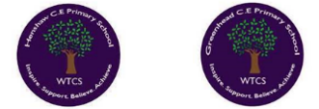
Greenhead CE Nursery and Primary School Newsletter
Newsletter No. 4 Autumn Term 2023
Friday 24th November

Greenhead
West Tyne Federation of Schools Northumberland
Executive Headteacher - Mr Mike Glenton NPQH, MEd, BSc (Hons) CA8 7HB
Assistant Head Teacher – Mrs Sherry Makepeace, BSc (Hons) Tel 016977 47347
Remembrance Day Celebration
We were honoured to be joined by Bishop Mark (the Bishop of Berwick) for our annual Remembrance Day Celebration at Holy Cross Church in Haltwhistle. The children sang beautifully and presented their words and poems clearly and with respect. It was truly moving to see both schools in our Federation perform together with the church choir. Check out the video of this wonderful celebration on our Facebook page.

Dogs on school premises
Please can we remind parents that, except for guide dogs, dogs are not permitted on the school premises. Although we do love our canine friends, we have a number of children who are anxious around dogs.
We thank you for your support in this.
A Message from the Head Teacher
We have made a great start to our second half of the autumn term with raising over £200 for Children in Need; thank you all for your generosity for this important charity. We have LOTS of enrichments coming up for the children; including a cinema visit for Key Stage 2 and a pantomime visit for Early Years and Key Stage 1. The school continues to subsidise the costs of these visits and the profits from our annual Bedtime Stories event next Thursday will raise funds for transport to these events.
Year 3 and 4 have started their ‘Kids Action Through Science’ workshops this week and will be visiting the Life Centre in Newcastle in a couple of weeks’ time. Year 5 and 6 will be visiting Haydon Bridge High School to explore the amazing Art and Design facilities and take place in Art workshops with a specialist teacher.
We love this time of year at school…. Although it is a lot of organisation to get ready for Christmas performances, the sound of songs and rehearsals fills the school corridors! I’m sure you share our eagerness to see all the children shine in these plays. As children are learning their words and songs, we have decided to forgo a homework project this half term, but this will be back after Christmas with a Science themed project. Please continue to access Spelling Shed and listen to your child read; it really does make a difference. Thank you for ensuring your child comes to school with a coat and we are starting to see hats and gloves appear each morning – wrap up everyone and keep warm. Best wishes, Mr Glenton

Clyde Class
In Clyde Class we have been creating an information text about space, including captions and diagrams. Linked to our English we have been reading Toys in Space and have been working on a retrieval skill. In Maths we have been continuing to work on addition and subtraction, year 1 have been using part whole models to solve calculations. In year 2 have been using base 10s to help us understand adding and taking away two 2-digit numbers. We have enjoyed our Science experiment linked to bubbles. We made a prediction about which soap mixture would make the most bubbles. To help support your child at home please make sure they continue to practise their lines for our Christmas Nativity.

Danube Class
Danube class have enjoyed revising their multiplication tables and making links to prior learning. They have been identifying different tenses in English and looking at how and why they are used. The children have been scientists and carried out an experiment to test soil around the school site. They have decided to plant tulip bulbs in 3 sites and we will monitor to see if their growth in spring matches our investigation results.
Mississippi Class
Mississippi class have been enjoying their dance lessons in PE and have been learning
Bollywood dance moves. In English, they wrote a story based in space and are now
beginning to plan a balanced argument around the question 'should humans live on
another planet?'. In science, we have been working scientifically and have conducted an experiment to see which substance cleans coins the most and how to make slime - ask your child if they can tell you about the results we found.

Early Years
Eden class have read the Mr Man story Mr Rush. The children looked at the characters and identified which 2D shape they were. We made our own Mr Men and could describe them using shape language. The children went on a shape hunt around the school grounds and were brilliant shape spotters! In PE we have started our gymnastics unit it was great to see that we can even make shapes with our bodies when performing different gymnastics holds. At home you could play shape I spy with your child and see if they can identify the object you are describing.
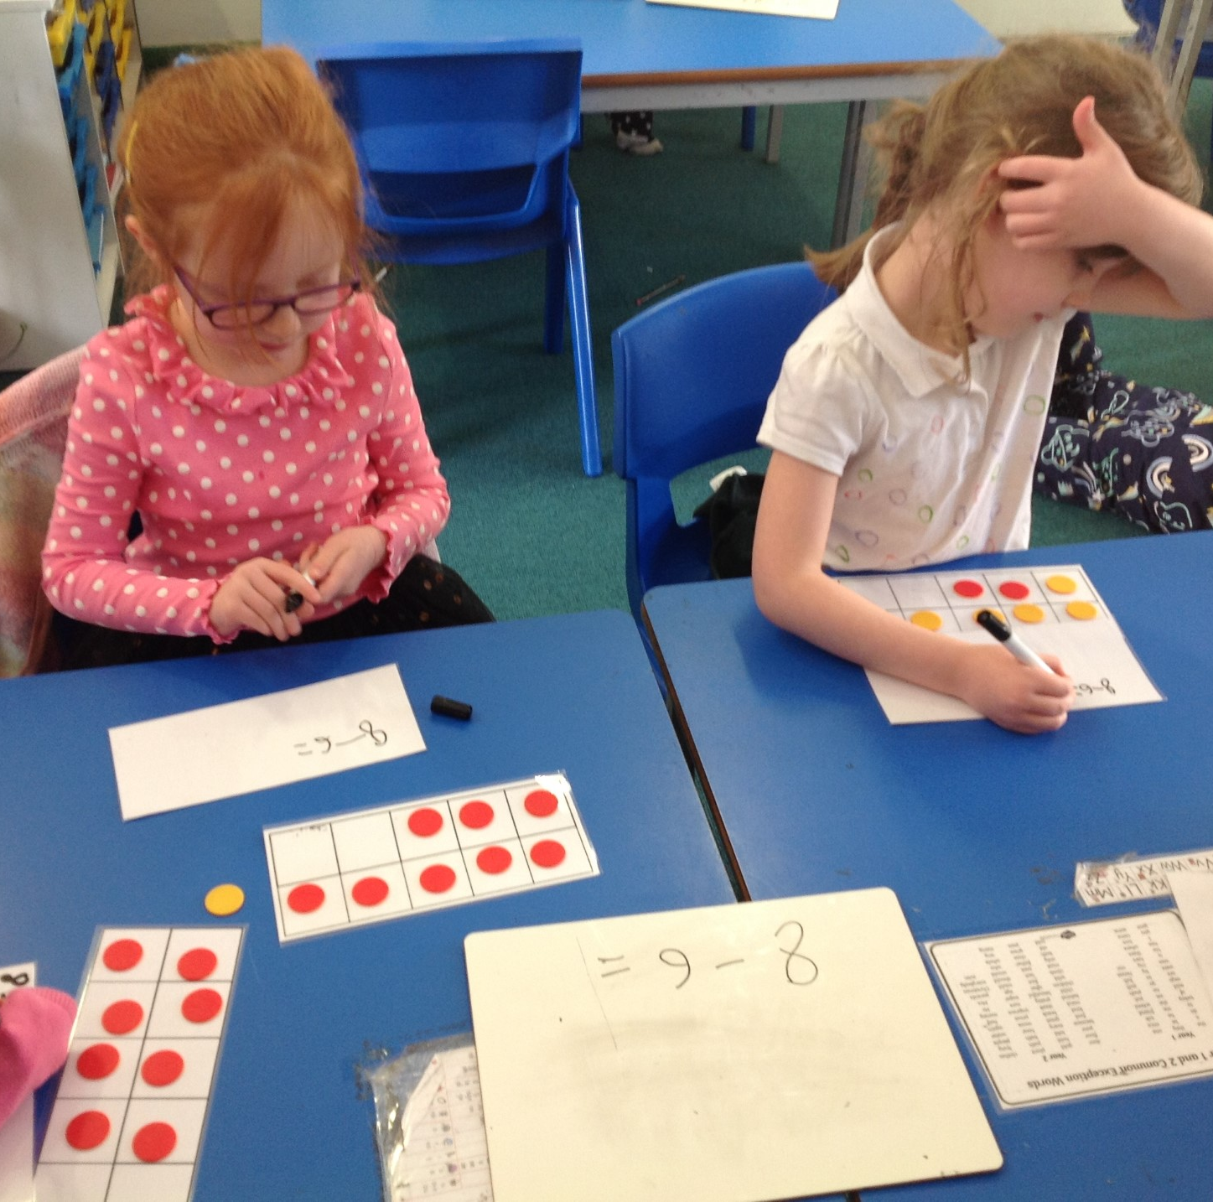
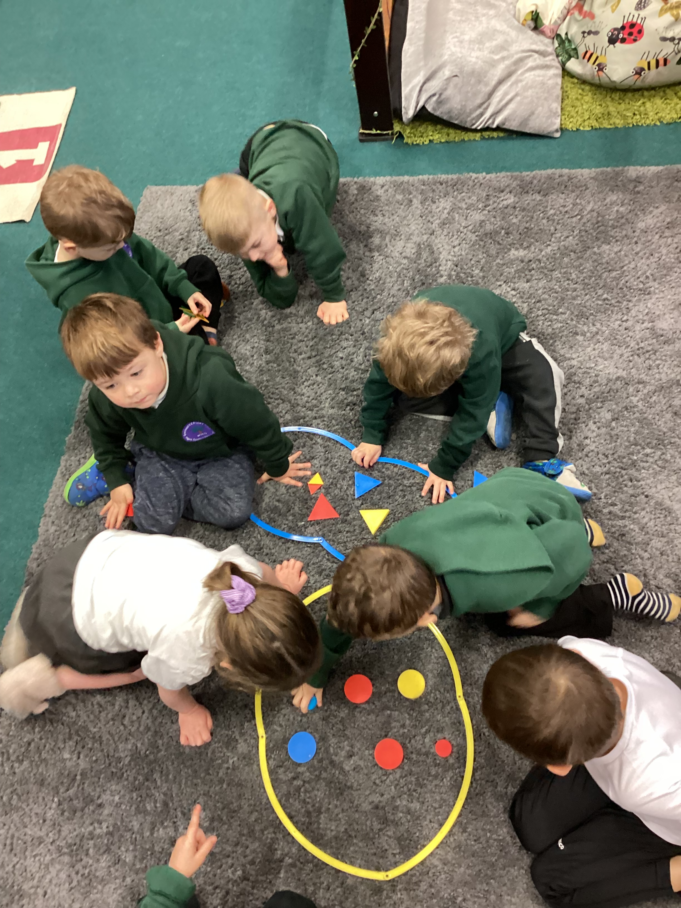
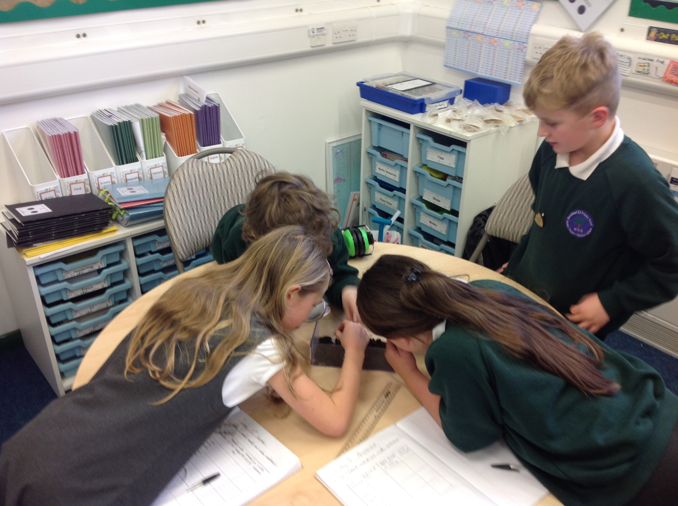

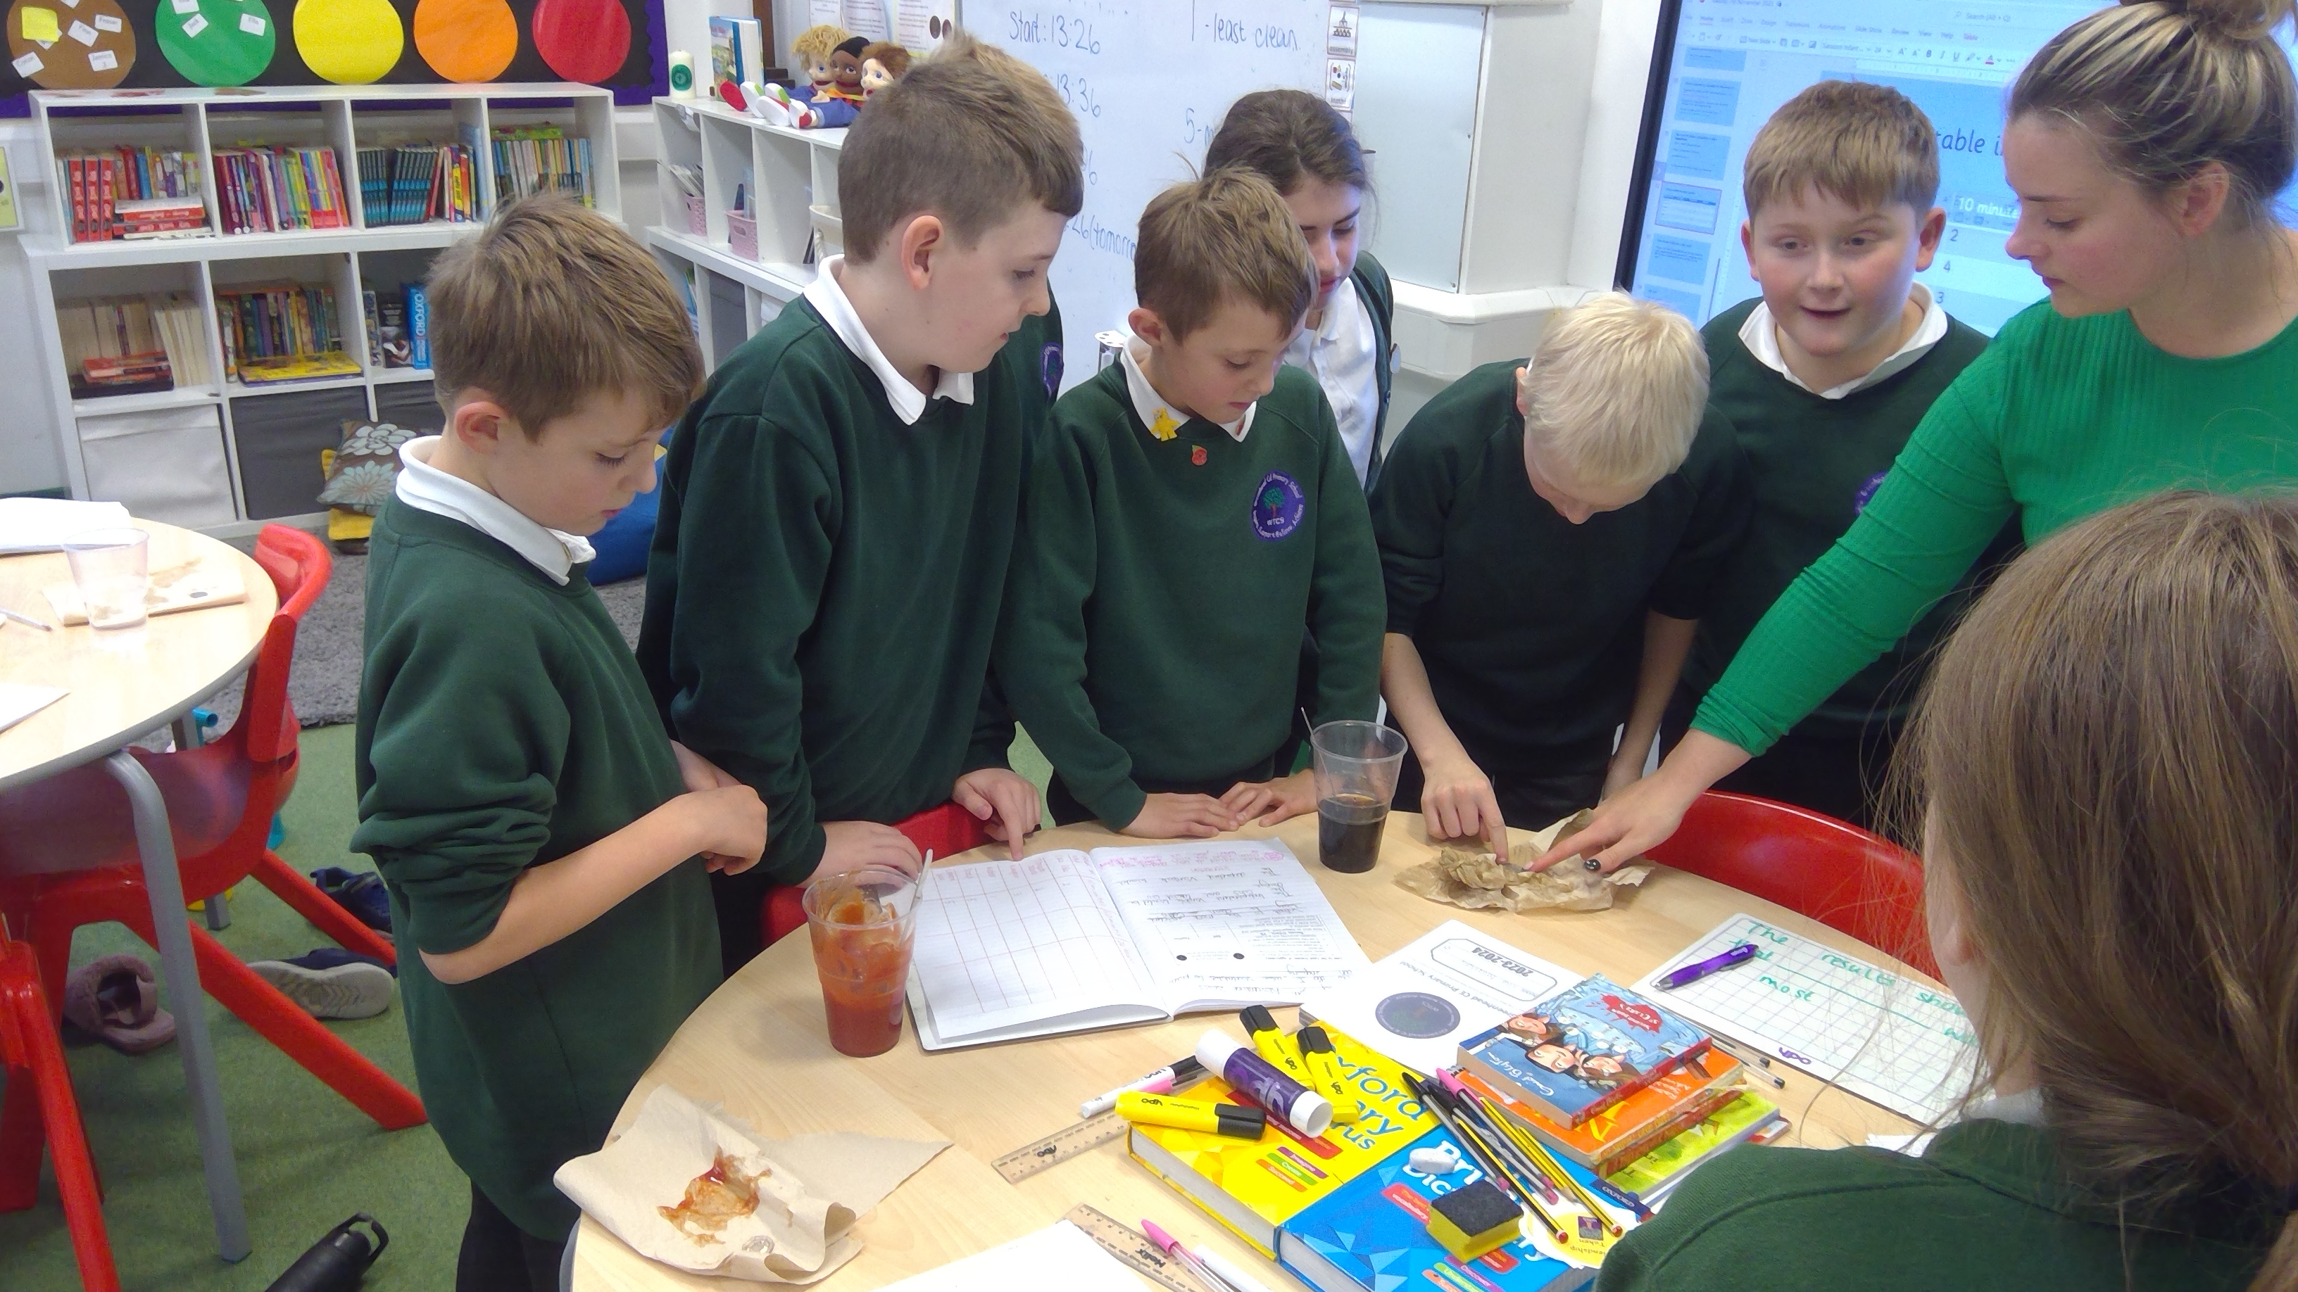
Class News

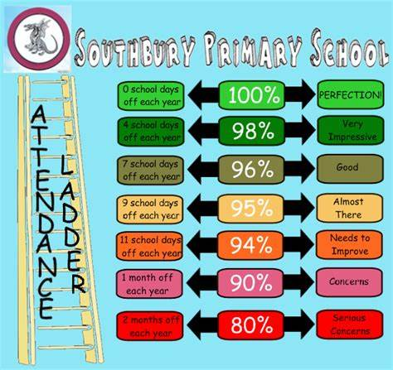
Bikeability
If your child is in Year 3, 4, 5 and 6, you should have received a letter regarding Bikeability which is taking place, starting next week. For these sessions, children will require a working bike and helmet. A small number can be hired from Bikeability, please let the office know if needed. Sessions will be run by external, trained professionals and children in past sessions have really enjoyed this opportunity. We are looking forward to seeing the children in action.
Our School Promise
Our School Promise reminds us of our vision and values that we hold dear at The West Tyne Church Schools Federation.
Well done to the following children for achieving their awards:
Learning Award – Layla, Ruby & Briar
Resilience & Teamwork Award – Paige, George F, Harrison & Briar
Etiquette Award – Lily, Harry
Environmental Award – Eco Council, Jack & George H
Kindness Award – Clyde class, Conan & Jessica B
Inclusion Award – Noah & Finn
Friendship Award – Jasper, Jessica J & Esther
Role model Award – Mississippi class & Freya
Attendance: Every day is important to give children their full entitlement to an exciting learning journey
Eden – 100%
Clyde – 92%
Danube - 100%
Mississippi – 97.14%

Whole School – 97.33%
A final thought…
What is Christmas? It is the tenderness of the past; courage for the present and hope for the future. Agnes Pahro
Dates for the diary
Week commencing; Monday 27th November – Bikeability training Y5/Y6
Thursday 30th November – Green Day
Thursday 30th November – Bedtime stories 4.30pm – 5.20pm
Friday 1st December – Kids Action Through Science – Workshop 2 for Y3/Y4
Friday 1st December – Art workshop and specialist teaching – Y5/Y6 to HBHS
Monday 4th December – Bikeability training Y3/Y4
Thursday 7th December – 2pm, Early Years and Key Stage 1 Nativity
Friday 8th December – Y3/Y4 visit to The Life Centre in Newcastle
Wednesday 13th December – Santa Dash at Breaktime (bring in a Christmas hat!)
Thursday 14th December – Y3 to Y6 to Haydon Bridge High School – Performance practise
Friday 15th December – Y3 to Y6 to HBHS – Performances 2pm and 4:30pm
Monday 18th December – Y3 to Y6 to Hexham Forum Cinema
Tuesday 19th December – Christingle Service at the church – parents welcome to attend
Wednesday 20th December – Reception to Y2 to Queen’s Hall Hexham - Pantomime
Thursday 21st December – Christmas Dinner Day and Christmas jumper day
Friday 22nd December – Class Christmas Parties (further information to follow)

Author visit
Year 5 and 6 were joined by published author, Andy Ruffell this week and had a wonderful time exploring his books and how he writes his stories. It was a great opportunity for the children to ask questions to a ‘real-life’ author and experience the process of using imagination and skill to write a novel.
A quick reminder - Christmas Dinner, Nativity and Performances
Year 3-6 will once again be performing their Christmas show at Haydon Bridge High School this year on Friday 15th December and the performances will be at 2pm and 4:30pm. The school will again subsidise the cost of transport for 2 days but we are asking for parents to purchase tickets for £2.00 each which will help pay for the remainder of this cost. Please see attached letter.
Reception and Year 1.2 will be doing their Christmas performance, in St Cuthbert’s Church on the Thursday 7th December at 2pm.
Our Christingle service at Greenhead Church will be on Tuesday 19th December at 9am, with adults welcome to attend. Christmas Dinner will be on Thursday 21st December.

