Greenhead CE Primary School Newsletter
Newsletter No. 2 Autumn Term 30th September 2022

Greenhead
West Tyne Federation of Schools Northumberland
Executive Headteacher - Mr Mike Glenton NPQH, MEd, BSc (Hons) CA8 7HB
Assistant Head Teacher – Mrs Sherry Makepeace, BSc (Hons) Tel 016977 47347
A Message from the Head Teacher
We have had a fantastic first half term at school with our Science Fair, NSPCC visitors and exciting, new online homework in the forms of TT Rockstars and Spelling Shed – what a lot of learning we have done already!
Staff have been hard at work this term as they continue to refine our curriculum, to give your children the best possible education and experience during their time at school. We have worked as a team to plan a year of enrichment and focus days which the whole school community can get involved with; please keep an eye on the dates for the diary section of the newsletter to keep up-to-date with what is coming.
A HUGE thank you to supporting us with our sponsored reading event – we will total the monies raised and be able to buy some wonderful books for the class and school libraries, to continue to enthuse the children in reading.
Just a few quick reminders; there will be no after-school club on Thursday 6th October due to teacher training. Also on the 6th October, at 9:30am, we have our Harvest Assembly and on the 15th October, at 9:00am, we have our Workshop Wednesday in school.

Best wishes, Mr Glenton

A message from our new SENCo (Special Education Needs Co-ordinator)
I would like to introduce myself - my name is Mrs Clarke. I am the special educational needs coordinator (SENDCo) across the Federation - It is my fifth year as SENDCo at Henshaw and I have now taken on the role at Greenhead too since September. It has been a pleasure to meet many of you face-to-face and also to communicate via email and telephone. I have been a SENDCo now for 26 years now and I am passionate about ensuring that all of our children have the necessary support in place to enable them to achieve their goals in life. I am really excited about working with you all going forward. If you need to contact me about your child and their needs at any time, my contact details are sendco@westtynefederation.uk.

Danube Class
In Danube class we have had a very exciting week. The children brought all of their fabulous Science projects from home to share with the rest of our classmates. The children found it really fascinating being able to present their work and ask questions about a wide range of interesting Science projects. We have also been learning about attacking strategies during PE. They have had the opportunity to play a variety of invasion games where they have had the opportunity to put these into practise. Parents, carers can continue to support children at home by encouraging them to read, learn their spellings and practise their times tables.
Clyde Class
This week we have been writing our information text about the Queen and learning about significant people, where we have been sorting them into different categories. We have enjoyed sharing and presenting our Science experiments and investigation to the class. During Maths Year 1 have been looking at less than a given number and Year 2 have been identifying tens and ones within a given number in a variety of ways. We have also taken part in our first whole school singing this week, where the children thoroughly enjoyed it.
To support your child's learning at home ask them to tell you what they remember from their reading book when you listen to them.

Eden Class

Mississippi Class

Class News

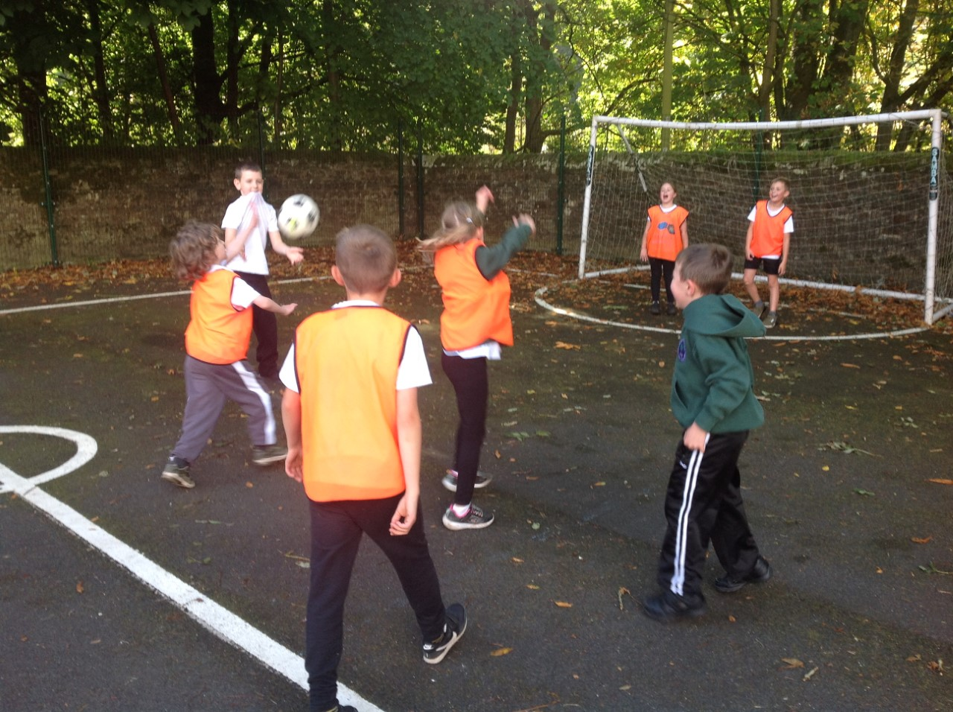
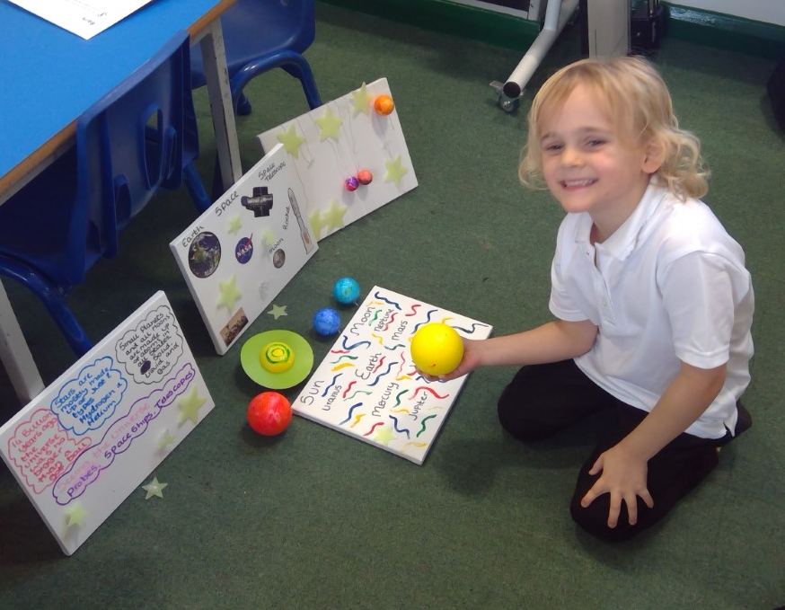

Parking at School
Thank you to all the parents who have not parked on our yellow, zig-zag lines since returning to school. This has really helped the taxis to get the children on and away quickly and safely - this new system is working really well. Staff are continuing to park in the school grounds (where possible) so the road outside is as clear as possible.

Our School Promise
Our School Promise reminds us of our vision and values that we hold dear at The West Tyne Church Schools Federation.
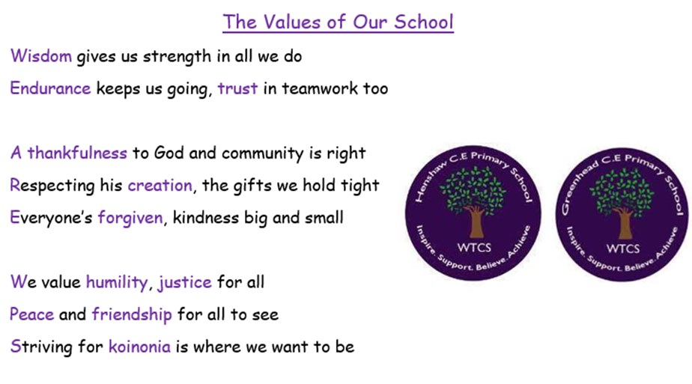
Staff nominate children who have shown these values in our schools and have been role models for our Christian values in our weekly Celebration Assembly.
Well done to the following children for achieving their awards:
Learning Award -
Resilience & Teamwork award –
Etiquette award –
Environmental award –
Kindness award –
Inclusion award –
Friendship award –
Role model award –
Each week, other children receive a postcard through the post to let their adults know how proud of them we are.
Attendance: Every day is important to give children their full entitlement to an exciting learning journey
Eden – Clyde – Danube - Mississippi –

A message from our Vicar, Father Steve
Harvest and Halloween
Coming up soon are our school harvest services, at St. Cuthbert’s Greenhead on Thursday 6th October at 9.30am, and at All Hallows Henshaw on Friday 7th October at 9.30am where the children will be singing and performing readings.
If you can’t make those, then there’s another chance – everyone is invited to a joint harvest celebration at St. Cuthbert’s Greenhead on Sunday 2nd October at 10am.
Help needed - Halloween service and party
On Sunday 30th October, you are invited to an All Hallows Evening service at Greenhead at 4pm. Part of the service will be by candlelight (but battery ones for safety with any fancy dress!). We would like to have a party for the children in the village hall afterwards but need some parents to help organise it. If you could help with that, please contact the vicar, Steve, on 01434 320215 or canonstevewright@gmail.com

Science Fair at Greenhead Primary School
I have been AMAZED at the wonderful science experiments and presentations I have seen in the past week. Thank you to you all for supporting our new homework projects and getting so involved. The children have been SO proud of their accomplishments and have talked with confidence and enthusiasm when sharing with the other children what they have done.
Dates for the Diary
Thursday 6th October – Harvest Celebrations at Greenhead Church 9:30am – parents/carers welcome
Monday 10th October – Nasal Flu immunisations at school
Monday 10th October – World Mental Health Day, activities in school
Wednesday 12th October - Workshop Wednesday 9:00am – 10:15am – parent/carers welcome
Monday 17th October – Councillor Trevor Cessford assembly – British Values
Wednesday 19th October – Year 3.4 Lindisfarne visit
Monday 31st October – Teacher Training Day – School closed to children

A final thought…
Great communication begins with connection Oprah Winfrey

