The Rainbow Nursery



GREENHEAD PRE-SCHOOL

Registered Charity No. 1150381

Guide for Parents/Carers

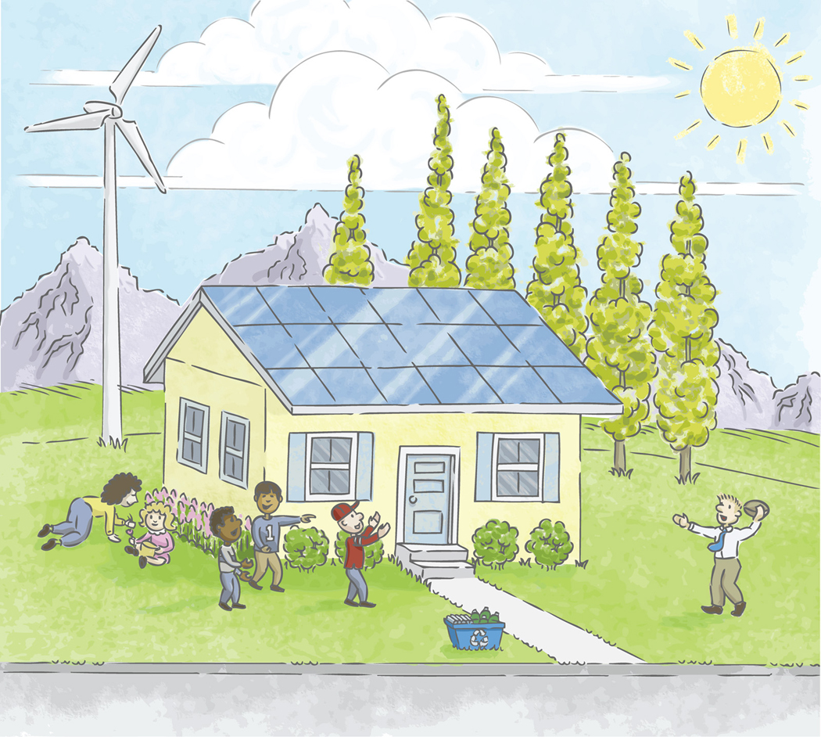

GREENHEAD PRE-SCHOOL
The Rainbow Nursery

Registered Charity No. 1150381

Greenhead Pre-school and Rainbow Nursery,
Behind Greenhead C of E Primary School Greenhead,

Brampton,

CA8 7HB.
Tel: 016977 47720

e-mail: greenheadpreschool@hotmail.co.uk

Dear Parents/Carers,

The staff of Greenhead Pre-school and Rainbow Nursery would like to say 'A very warm welcome'. We thank you for choosing our setting, knowing that your child will have a fabulous time with us. Your children are our first priority, and our aim is to provide accessible childcare and education in our warm, friendly, relaxed and happy setting, where each child is valued, appreciated and encouraged to reach their full potential through praise, sensitivity and mutual respect.

Although it is impossible to put every piece of information into this booklet, we hope this guide will be of help to you and give you an insight into how our setting operates. We wish to involve you in all aspects of nursery life in the knowledge that we will answer any questions you may have or provide you with any information you require.

Again, we would like to take this opportunity to welcome you all.

Kindest Regards. Beverly, Claire and Vicki ☺ ☺
____________________________________________________________________

About Us
We are a small, family orientated setting situated within the grounds of Greenhead C of E Primary School. Although an independent, limited company and a registered charity, we work very closely with ‘big school’ and share many wonderful experiences, enabling seamless transition into reception.
Our setting is managed by Company Directors made up of local people (see outside notice board), registered with Ofsted for full day care (see registration certificate displayed in the setting) and a member of the Pre-School Learning Alliance (PLA). A copy of our Early Years Inspection report is available for all parents/carers to read.

The day to day running of the nursery is handled by Beverley Barwick, Claire Brachtvogel and Vicki Teasdale. We work in accordance with the EYFS curriculum and plan a wide variation of activities that cover the EYFS Learning Intentions leading up to the Early Learning Goals. We are fully qualified, experienced, early years educators who regularly attend training, are DBS (Disclosure and Barring Service) and health checked and hold up-to-date first aid certificates.

Our setting provides:
- childcare for 2-5 years olds
- high ratios of qualified/experienced staff and staff cover
- time allocated to staff for development and ongoing training
- in the moment planning
- a safe and secure indoor/outdoor area
- outings and visits
- a range of resources appropriate to ages and stages of development
- shared activities in the school environment

Parents as Partners
You as parents are the most important people in your child’s life. We want to work in partnership with you to enhance and support your role at this very significant stage of your child's development. Parents possess a wealth of talent and you are invited to share those talents, eg. story telling, jobs you do, cooking activities etc. with us. You are most welcome to come into nursery to help for a couple of hours or lead the children in a particular activity as well as contribute to our planning and our online learning journal.

We strongly encourage you to be aware of our aims, policies and procedures and in particular, we ask that you respect our 'Mobile Phone' policy and not use mobile phones whilst in the setting or outdoor play area, and our ‘Social Networking’ policy requesting that you consider the reputation of our setting when posting on a public site.

As a charity, we welcome any fundraising ideas, and of course, much needed hands-on help at our fundraising events.

Staff are always available, and you are welcome at any time to share information or discuss your child’s progress etc. Staff will keep you informed at all times of how your child is progressing or of any concerns they may have. Also, parents mornings/afternoons are arranged to enable you to speak in more detail about your child’s progress or any other matter.

Admissions
Greenhead Pre-school and Rainbow Nursery is committed to equality of access and opportunity to learn and make progress, whatever the child’s age, gender, attainment, ethnicity, disability, special educational needs or competence in English. The setting welcomes applications from everyone and will respect and value every child’s needs. All children will be respected and their individuality and their potential recognised, valued and nurtured.

After your initial enquiry, you will be invited to visit the setting to view the facilities and talk to the staff about your child’s individual needs. If you choose a place at our setting, you will be given relevant forms to fill in to register your child. Information on these forms will include personal details about your child and family, medical details and any allergies or dietary requirements your child may have. *These forms will be required to be completed and returned to the setting prior to your child starting. Your child will be allocated a key person who will work closely with your child and you will be informed of which member of staff that will be (see ‘Working in Partnership with Parents). During this visit you will have the opportunity to ask any questions you may have and discuss the best strategies to help your child settle in.

We understand and empathise with parents/carers/children at the all-important, settling-in stage, and we at Greenhead Pre-School and Rainbow Nursery will work with you and respect your wishes as parent/carers to ensure your child settles in as easily as possible, in ways that apply to your child (see Admissions policy). There is no right or wrong way of doing this as every child is a unique individual, and a settling-in strategy that works for one child may not be what is required for you and your child. You may find it helpful and reassuring to meet with staff one month after your child starts nursery to discuss your child’s progress at an early stage.

We would encourage you to bring your child along to visit the setting prior to starting, to help your child become familiar with the provision. If requested, we will provide up to three preliminary visits, which gives you opportunities to leave your child for a short time if appropriate. There is no charge for these short visits.

Children’s names may be placed on the waiting list from birth with a view to starting as soon as you feel your child is ready (from two years of age). We welcome any child to visit, whether or not it is your intention to send your child to our setting.
*Parents/carers should inform staff of any significant changes to details as they occur, to enable us to keep our records up-to-date.

Times
Monday - Friday
Morning 9.00am – 12.00pm
Afternoon 12.00pm - 3.00pm
Full day 9.00am – 3.00pm

In conjunction with school, wrap around care is available for older children (during the term they will become four years old) from 8.00am to 5.00pm. For more information, please speak to Mrs. Tapscott on 016977 47347

Our setting is open during term time only and coincides with Greenhead C of E Primary School, i.e. it will close on designated Teacher Training days. You will be given a list of dates and there is always a list displayed in nursery.

We would appreciate it if you could bring your child promptly at 9.00am, but not before 9.00am as insurance cover is not effective before this time.

Funding and Payment of Fees
The cost for childcare is £4.50 per hour for non-funded children and also for any additional hours funded children may require.

Northumberland County Council provides funding for up to 15 hours per week for all Foundation Stage children i.e. 3 to 5 year olds (funding is available from the term after the child’s third birthday). Northumberland County Council provides free childcare for eligible children of up to 30 hours per week which can be divided between two settings. Funding is also provided for eligible two years olds eg. where parents/carers are in receipt of benefits that fit the criteria required by Northumberland County Council. To find out if your child is eligible for either please use the following link www.northumberland.gov.uk/freechildcare or speak with staff who will advise you.

Invoices are given out each half term and fees should be paid within 14 days of receiving them. If there are any problems with payment, you can confidentially speak with one of our managers at any time. If for any reason your child leaves the setting, we will require all fees to be paid in full.

____________________________________________________________________

Children’s Learning
It is recognised that the 'Foundation Stage' is a most important stage in the journey of life, and pre-schools were created to offer children a safe, satisfying, happy place to play, learn and develop with children of a similar age, before going on to school. Greenhead Pre-school and Rainbow Nursery aim to provide learning experiences through structured play for all children in the setting, with the involvement of parents/carers in all aspects of learning.

We aim to help your child develop at their own pace, through appropriate play activities, which both stimulate and challenge him/her – always keeping in mind your child’s personal interests – whilst working in line with the Early Years Foundation Stage (EYFS) curriculum. Every child is recognised as having individual needs and their own way of learning. They learn in many different ways - by playing, talking, observing, planning, doing, questioning, experimenting, testing, repeating, reflecting and responding to adults and each other. Well planned play, both indoors and outdoors is a key way in which children learn with enjoyment and challenge. The staff believe that young children learn most effectively when:
- they feel happy and secure in the environment
- are interested and involved in activities
- their work has purpose in a practical sense
- they have the support of adults who are interested and informed as to the purpose of their activity

- the experiences offered are relevant to their current interests
- their previous experiences and achievements are valued and used as a starting point to build on
- they are encouraged to be positive about themselves and have a pride in their achievements
- they are encouraged to make independent decisions about their learning and what they want to experience
- parents/carers are actively involved in their learning experiences

Our time in nursery is well planned in order to provide all children with a wide range of opportunities for both adult-led and child-initiated learning through play, thus enabling the development within the 'prime areas' of Personal, Social and Emotional Development (PSED), Communication and Language (CL) and Physical Development (PD) and the 'specific areas' of Literacy (L), Mathematics (M) Understanding the World (UW) and Expressive Arts and Designs (EAD).

All children follow an educational programme in accordance with government guidelines for the Early Years Foundation Stage (EYFS). The aim of all activities offered is for the children to learn through play with the intention of achieving the early learning goals by the end of their reception year in school.

Early Years Foundation Stage (EYFS)
Young children learn through play and children learn best when they are active in their own learning from experiences that are suitable for their stage of development. The EYFS concentrates on the individual needs of each child and their interests. This stage is known as the ‘Foundation Stage’, because it gives children secure foundations for later learning. Through play they develop the confidence and social skills needed for personal development and skills for writing and number work.

How children learn
Children learn by:
- finding out and exploring
- playing with what they know
- being willing to 'have a go'
- being involved and concentrating
- keeping trying
- enjoying achieving what they set out to do
- having their own ideas
- making links
- choosing ways to do things

Being supported by adults helps children to extend and develop spontaneous play. By building on children’s existing skills and interests and on their play activities, adults are able to expand their knowledge and help them to make good progress.

The Foundation Stage has seven areas of learning and development - 3 Prime areas which are fundamental, work together, and move through to support development in all other areas and 4 Specific areas which include essential skills and knowledge for children to participate successfully in society. In each of these areas there are learning intentions which lead up to the early learning goals. Children will progress towards these goals, but all children are individuals and will not progress at the same rate. It is hoped that all children will reach these goals by the end of the Foundation Stage.

Areas of Learning and Development

Personal, Social and Emotional Development (PSED)
Involves helping children to develop a positive sense of themselves, and others; to form positive relationships and develop respect for others; to develop social skills and learn how to manage their feelings; to understand appropriate behaviour in groups; and to have confidence in their own abilities.
Communication and Language (CL)
Involves giving children opportunities to experience a rich language environment; to develop their confidence and skills in expressing themselves; and to speak and listen in a range of situations.
Physical Development (PD)
Involves providing opportunities for young children to be active and interactive; and to develop their co-ordination, control, and movement. Children must also be helped to understand the importance of physical activity, and to make healthy choices in relation to food.
Literacy (L)
Involves encouraging children to link sounds and letters and to begin to read and write. Children must be given access to a wide range of reading materials (books, poems, and other written materials) to ignite their interest.
Mathematics (M)
Involves providing children with opportunities to develop and improve their skills in counting, understanding and using numbers, calculating simple addition and subtraction problems; and to describe shapes, spaces, and measures.
Understanding the World (UW)
Involves guiding children to make sense of their physical world and their community through opportunities to explore, observe and find out about people, places, technology and the environment.
Expressive Arts and Design (EAD)
Involves enabling children to explore and play with a wide range of media and materials, as well as providing opportunities and encouragement for sharing their thoughts, ideas and feelings through a variety of activities in art, music, movement, dance, role-play, and design and technology.

Progress Monitoring
Staff regularly observe and record what the children do in order to aid the planning of appropriate activities by carrying out focussed and incidental observations. Incidental observations are put onto ‘Tapestry’ an online learning journal as well as photographs of any significant pieces of work your child has done. Tapestry is available for you to look at and contribute to at any time.
All children are observed continuously and their developmental progress is monitored and recorded via the Northumberland county council school readiness checker. The information recorded is shared with parents and carers during partnership meetings. These meetings are very important in order to share key information about each child’s learning and development.

Time in Nursery
Children thrive on routine. As they become familiar with our routine they will begin to feel confident and secure in knowing what happens next, and what is expected of them. However, we will, and do, adjust our timetable to benefit the children.

Free Play
During this time the children are free to explore and take part in all of the activities that are set out or have access to our many other resources. Our activities are age appropriate and carefully planned to cover all the areas of learning and learning intentions. Although the session is ‘free play’, it is of course monitored for safety and suitability.

‘Listening and Learning’ Time
This a special time when the whole group come together. During this time children will register their names and spend a little time concentrating on letters and numbers, in a variation of ways. We often end with ‘news time’, when the children are encouraged to speak to the group if they wish to do so.

Snack Time
A time where children enjoy a healthy snack of fruit or toast. All children are given the choice of milk or water (fresh water is accessible at all times). This is an enjoyable social occasion where children can chat and learn valuable social skills. We ask if parents would kindly provide a piece of fruit or alternative healthy food items once or twice a week to be shared out at snack time.

Outdoor Play
Children have great fun in our large outdoor area where there are bikes, balls, hoops and a spacious playhouse and receive wonderful experiences exploring wildlife in the adjacent ‘Nature Garden’. During the winter months we ask that you provide your child with suitable footwear (wellies), and in summer, a protective sun hat. The nursery provides a suitable high factor sun cream, and with your consent, staff will apply as necessary. Parents are welcome to bring along their own if they wish to do so.

Lunch
Staff take the children into big school to eat their lunch alongside their older friends or brothers and sisters. They are welcome to have a cooked school dinner (to be paid for separately) or bring in a healthy packed lunch. The lunch menu is displayed in nursery.

Tidy Up Time
We love to see a messy nursery, however, we expect all of the children to tidy up, either when they have finished playing with something, or at a specific time when asked to do so. We turn this into a fun time for all and no child is expected to lift heavy boxes or put items in places that are out of their reach.

Nappy Changing
If your child wears a nappy it will be routinely checked and changed as necessary. The time of change will be noted and whether or not it is soiled. Although we keep spare nappies in the setting, in keeping with parental wishes, we ask you to provide nappies, wipes, cream etc. for your own child and place in a labelled bag.

Sleep
Although we have no separate room for children who wish to sleep or have a rest, we do have some comfy cushions and blankets. Sleepy children will be placed in the quiet area and will be checked and monitored throughout. A record will be kept of dates and sleep times.

Suitable Clothes
We want your child to be free to enjoy all the activities provided in nursery, therefore we request that you bring your child along in comfortable practical clothes that they can manage, and not their Sunday best!

Uniform is optional - we can order this for you - and ask that you put your child’s name on all your child’s clothing items (especially uniform).



