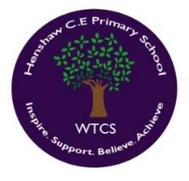
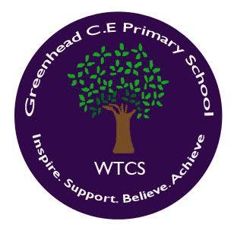
Art & Design Action Plan 2021-22

Art & Design Aims include:
- produce creative work, exploring their ideas and recording their experiences
- become proficient in drawing, painting, sculpture and other art, craft and design techniques
- evaluate and analyse creative works using the language of art, craft and design
- know about great artists, craft makers and designers, and understand the historical and cultural development of their art forms.

KEY PRIORITY
Objective | Actions and Responsibility | Success Criteria | Completion | Resources
- Children will be able to demonstrate the skills required for create art pieces through confident teaching that demonstrates the use of a range of media and artist techniques  - Children show progression throughout the school | - Monitor through looking at displays and floorbooks.  - Vocabulary linked to art clearly on display in classrooms  - Different media planned for and used. A larger range of artists and diversity in art considered by staff  - Lesson drop ins/pupil interviews, sharing of good practice between staff (what works well? What needs developing?)  - Encourage pupil feedback through call-outs about what they have enjoyed/found challenging  - Plastic wallets or something similar to store children’s finished pieces and show progression | - Children are using taught methods to create their  art. There is evidence that children have been  taught skills that lead to a finished piece of work  (photos to be taken of artwork)  - Children using technical vocabulary linked to art  - Children using mixed media (photos in floorbooks  and on display) showing a range of artists across  the year, perhaps also showing diversity  - Call-outs displayed  - Good practise shared and tried in classrooms by  Staff  - Staff are confident about how they teach, deliver  and assess art | Ongoing throughout the year. | Cornerstones Curriculum
- Staff have the confidence to teach art | - To share good practice through Floor Books and discussions with pupil voice interviews.  - Art lessons will be planned and be linked to other subjects, where possible.  - Pupil surveys/ interviews to check on wellbeing and support that is in place (pupil voice and engagement) | - Staff will be confident in delivering art lessons.  - Children will receive good quality teaching of art.  - Floor books will show that evidence has been recorded and show the impact of art along with pupil voice.  - Different aspects of art will be covered.  - Children will talk with confidence about artists and art. | Ongoing throughout the year. | Cornerstones Curriculum
- To ensure that units of work in the art rolling programme are well resourced and planned for, including resources for teaching using different media and artists | - Ensure that schools are well-resourced for the  art that is taking place. Schemes of work/resources to be catered for if necessary  - Teachers can share good practice across the federation  - Check with staff in each school that they have  the resources they need to teach  - ensure all children are accessing a broad and balanced art curriculum, including developing use of their sketchbooks; finding out about artists and craftspeople; revisiting opportunities to develop their use of colour, pattern, texture, line, shape, form and space; Cultural and personal development | - Resources will enhance the delivery of art lessons.  - Children will be eager to engage with new resources  and learning.  - Resources and consumables will be shared across  the Federation | Ongoing throughout the year. | Cornerstones Curriculum  Resources
SCHOOL DEVELOPMENT PLAN PRIORITY
- Ensure the needs of all pupils are met during lessons.  - All pupils are challenged during lessons. | - Teacher led discussions allow children to be more reflective, discuss their learning and take responsibility for their own development.
- To support Pupils mental health. | - Pupils to help support each other in a range of activities. | - Pupils feel more positive about themselves.  - Pupils to be more supportive of each other. | Ongoing
- To raise children’s aspirations and self-coaching skills. | - Children know what to do when they can’t do something.  - Pupils have regular opportunities to debate a range of issues which include those that are important to them. | - Pupils learn how to respect each other's viewpoints.  - Pupils have a more positive attitude towards school life.  - Pupil leaders to take an active role in school life. | Ongoing

