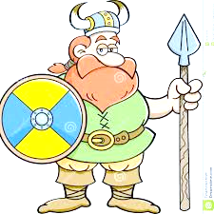
Our new topic is ‘Raiders and Traders.’ You will see that you have a choice of 12 different activities to choose from. I would like you to complete the highlighted activity as one of your activities, plus another 4.
Presentation is important. I will be looking for neat handwriting, labelled diagrams, photographs, organisational skills where bullet points or sub-headings have been used. You must show that you have tried and put as much effort into your work as you can. You can always complete more activities to earn even more points.
Please bring your homework book into school every Friday to show Mrs Fairless your completed weekly activity. All 5 activities to be completed by Friday 5th April 2019.
Enjoy ,
Mrs Fairless

