RE in LKS2 Cycle A
People of God: What is it like to follow God?
- I can make clear links between the story of Noah and the idea of covenant.
- I can make simple links between promises in the story of Noah and promises that Christians make (wedding ceremony)
- I can make links between the story of Noah and how we live in school and the wider world.
Incarnation: What is Trinity?
- I can identify John 1 as part of a Gospel, noting some differences between John and the other Gospels.
- I can offer suggestions what texts (John 1:1–14) about God might mean to Christians and give examples.
- I can describe how Christians show their beliefs about God the Trinity in the way they live.
- I can make links between some of the texts and teachings about God in the Bible and what people believe about God in the world today, expressing some ideas of their own clearly.
Sikhism: What does it mean to be Sikh in Britain today?
- I can identify some of the core beliefs of Sikhism (one God, the message of Guru Nanak)
- I can make clear links between the Mool Mantar and Sikh beliefs and actions.
- I can make simple links between the life of at least one of the Gurus and some actions Sikhs take today (Guru Nanak and the Langar, Guru Gobind Singh and the Khalsa).
- I can give some examples that demonstrate that remembering God, working hard and serving others are important to Sikhs today.
Salvation: Why do Christians call the day Jesus died ‘Good Friday’?
- I can order Creation and Fall, Incarnation, Gospel and Salvation within a timeline of the Bible’s ‘big story’.
- I can offer suggestions for what the texts about the entry into Jerusalem, and the death and resurrection of Jesus might mean to some Christians.
- I can make simple links between the Gospel texts and how Christians mark the Easter events in their church communities.
- I can make links between some of the stories and teachings in the Bible and life in the world today, expressing some ideas of my own clearly.
Kingdom Of God: When Jesus left, what was the impact of Pentecost?
- I can make clear links between the story of the Day of Pentecost and Christian belief about the Kingdom of God on Earth.
- I can offer suggestions about what the description of Pentecost in Acts 2 might mean to some Christians.
- I can make simple links between the description of the Day of Pentecost in Act 2, the Holy Spirit and the Kingdom of God and how Christians live their whole lives and in their church communities.
- I can make links between ideas about the Kingdom of God explored in the Bible and what people believe about following God in the world today, expressing some of their own ideas.
Thematic: What are the deeper meanings of festivals?
- I can identify the main beliefs at the heart of religious festivals (Diwali, Sikh New Year and Christmas)
- I can make clear links between these beliefs and the stories recalled at the festivals.
- I can make connections between stories, teachings and beliefs and how believers celebrate these festivals.
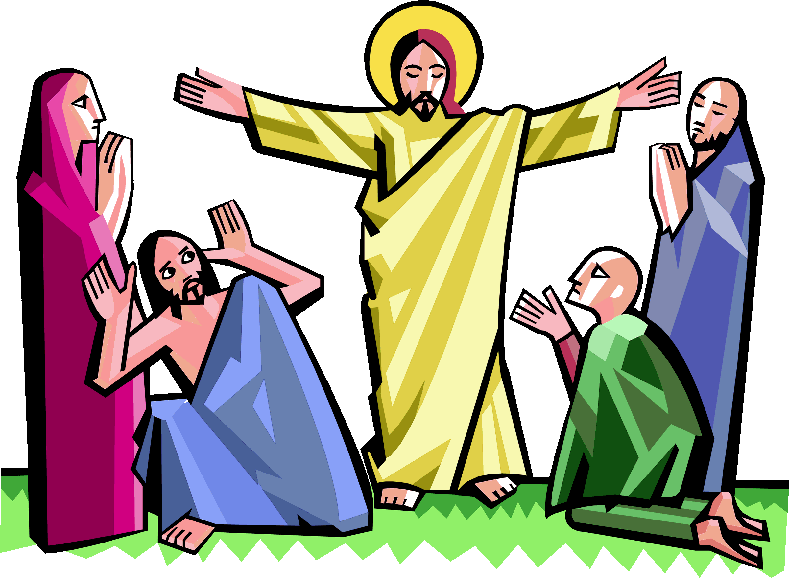
- I can raise questions and suggest answers about what is worth celebrating and remembering in religious communities and in my live.

