Music in Key Stage 1
- I can listen and respond to music from different styles (reggae, hip-hop, blues, pop, classical, rock, Afropop and bossa nova).
- I can find the chorus or answer/response part in some songs.
- I can learn how some songs tell a story or describe an idea (feeling happy, space travel, animal characteristics, being friends).
- I can express myself by moving to music in different ways (dancing, marching, role play).
- I can create rhythms from words and instruments (saying my name, animals, food, colours, percussion).
- I can add high and low sounds when I sing and play instruments.
- I can develop my awareness of pulse, rhythm and pitch.
- I can sing in unison with others and take part in whole school singing lessons.
- I can learn about different ways voice is used in music (singing, spoken word with rhythm – rap, sounds and notes to keep a beat).
- I can learn the notes of an instrumental part from memory or when written down.
- I can name some untuned percussion (bongos, djembe, tambor, tambourine, claves, woodblock, castanets, maracas).
- I can play a tuned instrument (glockenspiel, recorder or keyboard) along with a song, keeping a steady pulse.
- I can use my voice and instruments to improvise in different sections of songs.
- I can compose a simple melody using one, three or five notes.
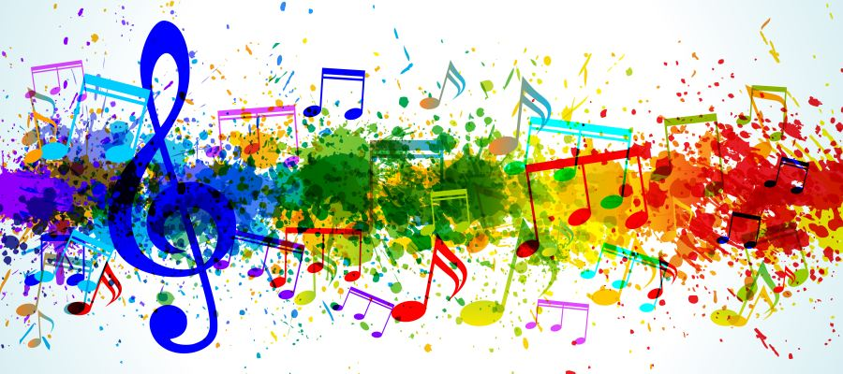
- I can perform to another group (in assembly, Christmas production and our end of year production).

