Hola Mexico LKS2 Homework

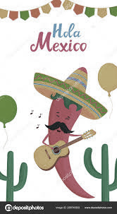
This term our new topic is Hola Mexico. You have 11 different activities to choose from. As this is a seven-week term I would like you to complete 4 activities. The dates to hand your topic homework in are as follows:
Thursday 11th June 2020
Thursday 25th June 2020
Thursday 9th July 2020
Thursday 16th July 2020
I expect you to put as much effort into your homework as possible. By high expectations I mean:
- presentation should be neat, with writing either in pencil or pen depending if you have achieved your pen licence, please don’t use felt tip pens.
- writing should be on the lines, with any headings or sub-headings underlined
- work should be presentable not rushed the night before.
- Any diagrams, pictures or photographs should be labelled and have a caption underneath.
- Organisational devices such as bullet points, numbers, sub-headings can be used to help the reader.
- If a creative activity has been submitted then an explanation should still be written in your book explaining how you made your model and why you used certain resources.
- Any pictures or photographs need to be stuck in your book.
- Write information out in your own words, don’t just copy and paste.
- Each piece of homework should clearly state which activity you have picked. This can be either done by writing out the activity or stating which number activity it is.
You should be proud of your work and remember the more effort you put in the more points you will achieve. A prize will be awarded to the child who has gained the most points. This will be announced the last day of term Friday 16th July 2020.
You can use books in class and the laptops for research purposes during lunchtime.
Any problems or concerns then please let Mrs Fairless know.
Thank you and good luck!
Mrs Fairless

